Group Business | CEIS Ayrshire
Job Title | Key Worker
Department | Employability Services
Name of Post Holder
Reports to (Job Title) | Employability Team Leader
Organisation Chart
(showing job in context of Group Business)
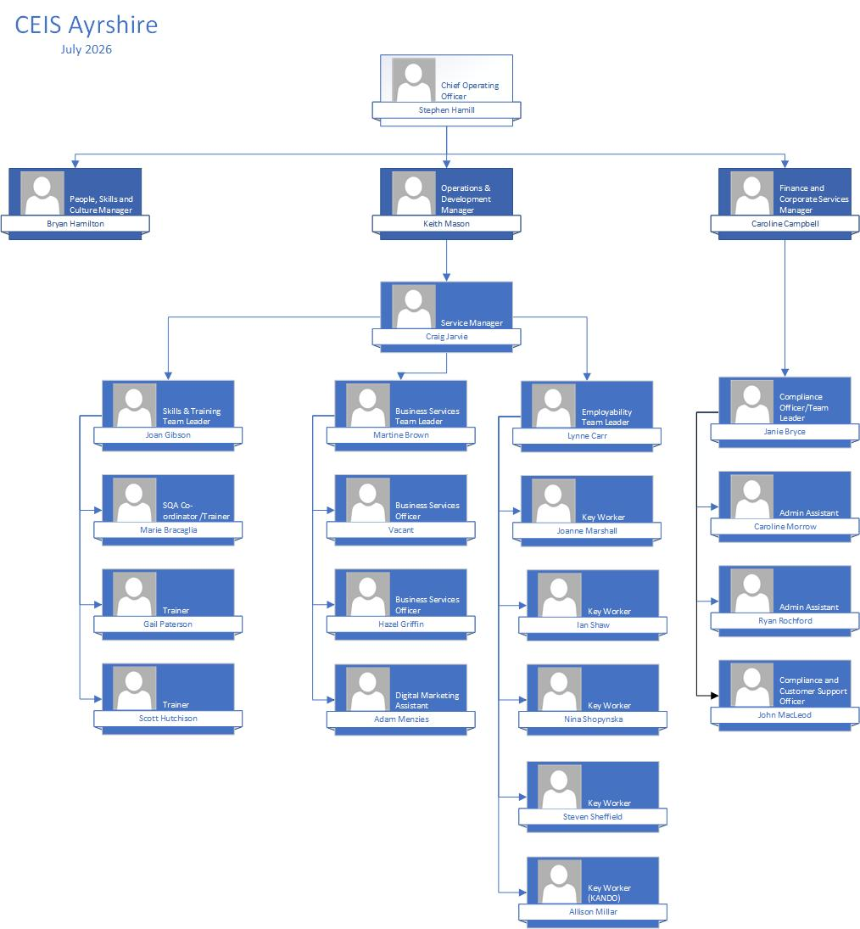

Location
North Ayrshire
Contract
Permanent
Hours
Full-time
Salary
£25,000
Job Context
(a description of the job in the context of where it fits in the overall structure of the Group Business and beyond if required).
Role Overview

Key Workers are at the core of CEIS Ayrshire's employability services and provide a consistent point of contact for individuals accessing support.
Working as part of the Employability Team, and collaboratively with Skills & Training, Business Services and external partners, Key Workers provide person-centred employability support to help individuals identify and reduce barriers, develop their skills and confidence, and progress towards sustainable employment, education or further training.

Key Workers are responsible for managing a caseload of clients, assessing individual needs, agreeing realistic goals and developing action plans that support progression. Support will be tailored to the needs of each individual and may include employability support, CV development, job searching and applications, interview preparation, access to training, work experience, employer opportunities and referrals to specialist services.

The role requires proactive engagement with clients and partners, effective caseload management, accurate recording of activity and outcomes, and a clear focus on achieving individual progression and contractual performance targets.

Job Purpose
(a description of what the job entails and why it exists).
Job Purpose

The purpose of the Key Worker role is to support individuals to overcome barriers and make sustainable progress towards employment, education or further training.

The post holder will:

- Carry out comprehensive initial and ongoing assessments to identify clients' strengths, aspirations, support needs and barriers to progression.
- Work collaboratively with clients to develop and regularly review individual action plans with clear, achievable goals.
- Provide tailored one-to-one and group employability support based on individual needs.
- Support clients to identify and address barriers including skills gaps, confidence, work readiness, financial or practical barriers and other circumstances affecting progression.
- Support clients with CVs, applications, job searching, interview preparation and other employability activities.
- Identify and facilitate appropriate training, qualifications, work experience and other development opportunities.
- Work collaboratively with Business Services Officers to identify suitable vacancies and employer opportunities and support effective job matching.
- Work collaboratively with Skills & Training colleagues to identify appropriate training and development opportunities.
- Refer and signpost clients to specialist and partner services where additional support is required.
- Maintain regular, purposeful contact with clients and proactively re-engage individuals who disengage from support.
- Provide appropriate in-work support to help clients sustain employment and achieve relevant employment outcomes.
- Develop and maintain effective relationships with employers, community organisations, Local Authorities, DWP and other relevant partners.
- Maintain accurate, timely and comprehensive client records, action plans, evidence and outcome documentation.
- Manage an allocated caseload effectively, prioritising activity according to client need, progression opportunities and contractual requirements.
- Contribute towards individual, team and organisational KPIs, including engagement, registrations, progression, employment and sustained outcomes.
- Use performance information and caseload data to identify clients requiring additional intervention and opportunities to improve outcomes.
- Ensure services are delivered in accordance with contractual requirements, CEIS Ayrshire policies, data protection requirements and quality standards.
- Contribute positively to team meetings, case discussions, service improvement and the development of CEIS Ayrshire's employability provision.

Assignment and Review of Work
(who the post holder reports to, and who will review their work, how and when this will happen).
The overall job role will be agreed by the Employability Team Leader and the Service Manager. Prioritisation and twice-yearly review of work will be done with the Employability Team Leader and reported to the Service Manager and Operations & Development Manager.
Key Deliverables
(a numbered list of the major KPIs and KDIs for the job).
Key Deliverables

Client Engagement, Assessment & Support

a. Build positive, professional and supportive relationships with clients, using a person-centred approach to encourage engagement and progression.
b. Complete effective initial and ongoing assessments to identify clients' strengths, aspirations, skills, support needs and barriers to employment, education or further training.
c. Work collaboratively with clients to develop, agree and regularly review individual action plans with clear and achievable progression goals.
d. Provide tailored employability support including CV development, job search, applications, interview preparation and work-readiness support.
e. Identify and coordinate appropriate interventions including training, qualifications, work experience, specialist support and partner services.
f. Proactively engage and re-engage clients to maintain meaningful contact and support continued progression.
g. Recognise when clients require additional or specialist support and make appropriate referrals to internal or external services.

Caseload, Progression & Performance Management

a. Effectively manage an allocated caseload, ensuring clients receive appropriate and purposeful support according to their individual needs and agreed action plans.
b. Take ownership of client progression and proactively identify the actions and interventions required to move clients towards employment, education or further training.
c. Prioritise workload and client activity according to individual need, progression opportunities and contractual requirements.
d. Contribute towards agreed individual, team and organisational performance targets and Key Performance Indicators (KPIs).
e. Use caseload and performance information to monitor client engagement and progression, identify stalled cases and take appropriate action.
f. Support clients to achieve sustainable employment outcomes and provide appropriate post-employment/in-work support.
g. Maintain appropriate contact with clients following progression into employment to support sustained outcomes and relevant contractual requirements.

Joined-Up Service & Partnership Working

a. Work collaboratively with Business Services colleagues to identify suitable vacancies, employer opportunities, work experience and progression routes for clients.
b. Work collaboratively with Skills & Training colleagues to identify and coordinate appropriate training and development opportunities.
c. Develop and maintain effective relationships with Local Authorities, DWP, training providers, community organisations and other relevant partners.
d. Refer and signpost clients to specialist services where needs or barriers require support beyond the Key Worker's role.
e. Participate in case discussions and joined-up approaches where appropriate to ensure clients receive coordinated and effective support.
f. Maintain awareness of local labour market opportunities, employer needs and available provision to inform client action planning and progression.

Recording, Compliance & Quality

a. Maintain accurate, timely and comprehensive records of client contact, activity, progression and outcomes using appropriate CEIS Ayrshire systems and databases.
b. Ensure assessments, action plans and client records accurately reflect individual needs, agreed actions and progress.
c. Collect, maintain and submit appropriate evidence to support registrations, activity, claims, outcomes and sustained outcomes.
d. Ensure referrals, job matches, training activity, outcomes and other relevant interventions are recorded accurately and within required timescales.
e. Maintain documentation to the standards required by CEIS Ayrshire, funders and relevant contractual requirements.
f. Ensure client information is handled appropriately and in accordance with data protection, confidentiality and organisational requirements.
g. Respond appropriately to internal and external audit findings and contribute to maintaining high standards of compliance and service quality.

Communication & Professional Relationships

a. Demonstrate effective verbal, written and listening skills when working with clients, colleagues, employers and partner organisations.
b. Communicate information clearly and appropriately, adapting communication to meet individual client needs where required.
c. Conduct all interactions professionally and provide a high standard of customer service.
d. Attend and contribute positively to team meetings, case discussions, service meetings and other organisational activities as required.
e. Maintain effective communication with colleagues across CEIS Ayrshire to support coordinated service delivery and client progression.
f. Represent CEIS Ayrshire professionally when engaging with employers, partners, stakeholders and the wider community.

Team Contribution & Continuous Improvement

a. Contribute positively towards team and organisational objectives, targets and service priorities.
b. Take responsibility for personal organisation, workload management and professional standards.
c. Participate in relevant training and development opportunities and maintain knowledge appropriate to the role.
d. Contribute ideas and feedback to improve client experience, operational processes and service delivery.
e. Use performance information, client feedback and professional experience to identify opportunities for service improvement.
f. Work flexibly across CEIS Ayrshire services and locations where reasonably required to support operational delivery.
g. Apply and adhere to CEIS Ayrshire policies, procedures, Code of Conduct and organisational values.
h. Demonstrate integrity, professionalism and respect in all aspects of the role.
i. Undertake other reasonable duties appropriate to the role as directed by the Employability Team Leader or Service Manager.
Responsibility for Resources (direct or indirect)
(both human and other resources, description of other resources (if any).
Number of people: N/A
Their Job types: N/A
Budgets:
Communications and Working Relationships
Internal (within the CEIS Group)
Business Services Team  Skills & Training Services Team  Corporate Services Admin |  | Liaise over clients/employers  Liaise over client training  General support services
External (outwith CEIS Group)
Local Authorities  Other statutory agencies and key stakeholders |  | Awareness of political environment, partnership working through Working North Ayrshire  Eg DWP, partnership working for client interests, resolution of conflicting interests.
Job Requirements
(qualifications, skills and experience – for job not specific job holder.
Role Challenges and Essential Requirements
- Experience of case management, employability or a relevant client-facing support role.
- Ability to assess client needs, identify barriers and support progression towards employment, education or further training.
- Effectively manage a caseload and take ownership of client progression.
- Ability to work towards agreed performance targets and outcomes.
- Strong organisational and time-management skills with the ability to prioritise competing demands.
- Excellent communication and interpersonal skills.
- Ability to maintain accurate records and meet quality and compliance requirements.
- Work independently, use initiative and adopt a proactive, solutions-focused approach.
- Build effective working relationships with colleagues, employers, partners and other stakeholders.
Essential: | Essential Criteria  - Demonstrable ability to engage, build rapport and maintain effective professional relationships with individuals from a wide range of backgrounds.  - Understanding of the barriers and challenges that may prevent individuals from progressing into employment, education or further training.  - Ability to assess individual needs and develop appropriate action plans and interventions to support progression.  - Ability to effectively manage an allocated caseload, prioritise workload and maintain purposeful client contact.  - A proactive and solutions-focused approach to supporting individuals to overcome barriers and achieve agreed outcomes.  - Ability to work towards and contribute to agreed performance targets and Key Performance Indicators.  - Strong organisational and time-management skills, with the ability to manage competing priorities effectively.  - Excellent verbal, written, interpersonal and listening skills.  - Ability to work collaboratively with colleagues, employers, partner organisations and other stakeholders.  - High standards of professionalism, integrity, confidentiality and attention to detail.  - Sound digital literacy and the ability to accurately maintain client records and use data and case-management systems.  - Ability to interpret basic caseload and performance information to prioritise activity and identify clients requiring additional intervention.  - Work independently while contributing effectively as part of a team.  - Commitment to CEIS Ayrshire's values and to delivering a high-quality, person-centred service.
Desirable: | Desirable Criteria  - Previous experience within employability, employment services, community development, careers, training or another relevant support environment.  - Experience of managing a client caseload and supporting individuals towards employment or other positive progression outcomes.  - Knowledge of the local labour market and the challenges affecting individuals seeking employment.  - Knowledge of local employability, training and community support  - Experience of partnership working with employers, Local Authorities, DWP, training providers or community organisations.  - Understanding of funded employability programmes, contractual requirements and evidence/compliance processes.  - Relevant qualification in employability, careers guidance, community development, social care, education or another related discipline.

Signature of Postholder
Signature of Manager
Job Description Compiled by
BH/CJ
Date Completed/Revised
26/08/2026
Job description should be reviewed annually

